Initial Client Intake Form

Name
Address
City, State, Zip
Phone
Date of Birth
Occupation
Emergency Contact

Prior Massage Therapy Care
Have you had a massage before? | NO
 | YES If yes, Wellness? Clinical?
If you have had clinical massage to work on specific symptoms, which of the following regions?  Please circle | Upper back  Mid back  Low back  Neck  Shoulder R / L  Thigh R / L  Knee R / L  Hips R / L  Lower Leg R / L
LifeStyle
Tobacco Use?  Sugar Use?  Exercise?  Sleep / night? | High Medium Low  High Medium Low  High Medium Low  4-6 6-8 8-10 10+

Please Circle your answer, or write in as appropriate.
Are you currently under the care of a doctor? Y N

Are you under the care of a chiropractor? Y N
If yes, how long?
For what symptoms?

Are you aware of any reason you should not be receiving massage? Y N

Falls or accidents – list type and date:

Surgery and operations – list type and date:

Do you have a history of allergies? Y N

Are you allergic to nut based oils? Other skin allergies? Y N

Have you been treated for cancer within the last 5 years? Y N
If yes, is your doctor aware you are seeking massage? Y N

Have you, or are you aware of, any circulatory problems? If yes, Explain Y N

Do you have a history of blood clots? Y N

Do you have a history of hemophilia, or take blood thinners Y N

Please list any medications or drugs you are taking that may be affected by an increase in blood or lymph circulation

If you have taken any medications today (particularly pain relievers or blood and heart related meds), please note the time and type of medication

Please indicate reason for massage today if it is of a clinical nature
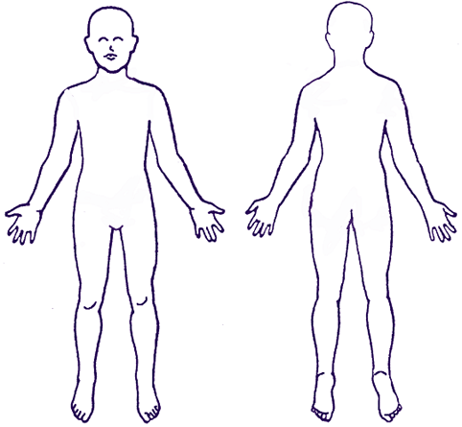
Please indicate pain sources and character:

Numbness: •••

Pins & Needles 000

Burning: XXX

Aching: ***

Stabbing: ///

Range of Motion:
Flex Extend Lateral R Lateral L Rotate
Cervical
Shoulder
Elbow
Hip
Knee
Wrist
Ankle

Postural Assessment (for Therapist Use)

Please check the appropriate box for any type of the following symptoms that you have
now or have had previously.

Signature: _________________________________ Date: _____________

Informed Consent Statement

I hereby request and consent to the performance of massage therapy and related procedures, including hydrotherapy, by Geraldine Lampert. Geraldine Lampert is a licensed CMT in the state of Illinois.

I have had the opportunity to discuss with the massage therapist the nature and purpose of the massage therapy session and related procedures. I understand that there is no implied or stated guarantee of success or effectiveness of this massage session.

I further understand there are some very slight risks associated with massage therapy sessions. These risks may include, but are not limited to, bruising, and muscle soreness. I do not expect the massage therapist to be able to anticipate and explain all risks and complications. I acknowledge that massage therapy is not a substitute for medical care, medical examination, or diagnosis. I have stated all medical conditions that I am aware of on the Client History Form.

I have been made aware of the risks of massage as they relate to people with blood clots or who have been treated for cancer.

I further understand that this is a clinical massage environment.

I have read the above Informed Consent Statement. I have also had the opportunity to ask questions about its contents, and by signing below I agree to the above mentioned massage therapy session.

Please print:

____________________ ______________________ ___________
Name of client Signature of client Date

Geraldine Lampert______ ______________________ ____________
Name of Therapist Signature of Therapist Date

